PROJECT REPORT ON

**E -Commerce Platform (Amazon Clone)**

Submitted By

**Vedant Sandip Yeola**

**INDEX**

1. Introduction
2. Project Overview
3. Objectives
4. Technology Stack

* HTML
* CSS
* JavaScript
* Bootstraps

5.Features

* **User Interface:**
  + - Clean and intuitive UI inspired by Amazon.
    - Dynamic hover effects and animations.
    - Navbar with search functionality, account options, and cart.
    - Well-structured panel sections with categorized navigation.
    - Grid-based product layout with hover zoom effects.
    - Interactive product cards with scaling and shadow effects.
    - Shopping cart functionality with order summary.
    - Secure checkout process.
* **Billing Page:**
* Invoice-style bill generation.
* Highlighted total amount with color-coded sections.
* Success message and navigation options.

**6.Future Enhancements**

* Implement login/signup functionality with user authentication
* Provide order history and personalized recommendations.
* **Payment Gateway Integration:**
  + Enable real-time payment processing via UPI, Credit Card, etc.
  + Secure transactions with encryption.

**7. Conclusion**

**Introduction:**

The **Amazon Clone Project** is a web-based e-commerce platform designed to replicate key functionalities of Amazon. This project includes features such as a dynamic homepage, product listings, a shopping cart, user authentication, and an order receipt system. The interface is designed to be visually appealing and user-friendly, ensuring a seamless shopping experience.

Built using **HTML, CSS, JavaScript, and Bootstrap**, the platform incorporates responsive design principles to ensure accessibility across various devices. The project also includes a billing page that mimics Amazon’s invoice system, enhancing the real-world feel of the shopping experience.

This project aims to provide a **realistic e-commerce experience** while also serving as a foundation for future enhancements such as **order tracking, payment gateway integration, and personalized recommendations**.

**Project Overview:**

The application allows users to:

* **User-Friendly Navigation** – A clean and intuitive navigation bar for seamless browsing.
* **Product Listings** – Multiple product categories displayed with images, descriptions, and prices.
* **Search Functionality** – A functional search bar to quickly locate products.
* **Shopping Cart System** – Users can add/remove products and view their total price
* **Billing Page** – A dynamically generated order receipt after checkout.
* **Responsive Design** – Optimized for desktops, and tablets devices.

**Objectives:**

* **Product Catalog**: Display products with images, descriptions, prices, and categories.
* **Shopping Cart**: Provide a cart system where users can add/remove items.
* **Checkout & Billing**: Generate an interactive and dynamic bill/receipt page with order details.

**Technology Stack:**

* **HTML5: –** Provides the structural foundation for web pages, ensuring semantic and SEO-friendly markup.
* **CSS3:** – Enhances the styling with modern features like Flexbox, Grid, and animations for an engaging UI.
* **JavaScript (ES6+):** – Implements dynamic functionalities such as dropdowns, modals, and interactive elements.
* **Bootstrap 5:** – Ensures a responsive and mobile-first design with prebuilt UI components.
* **jQuery:** – Simplifies DOM manipulation, event handling, and AJAX for asynchronous data fetching.
* **Font Awesome & Icons:** – Enhances user experience with scalable, visually appealing icons.

**Features:**

1. **Responsive Navbar:** – Includes search bar, cart, and account options
2. **Product Listings:** – Displays various products with images, prices, and descriptions.
3. **Shopping Cart:** – Add, remove, and update products in the cart.
4. **Checkout & Payment Integration:** – Processes orders with payment gateway integration. methods such as credit/debit cards, UPI, net banking, and digital wallets
5. **Order Confirmation Page:** – Displays order details after successful purchase.
6. **Hero Section & Banners:** – Engaging homepage design with promotional banners.
7. **Footer with Links:** – Includes important pages like About, Contact, and Policies.

**Screenshots and Outputs:**

**HOME PAGE:**

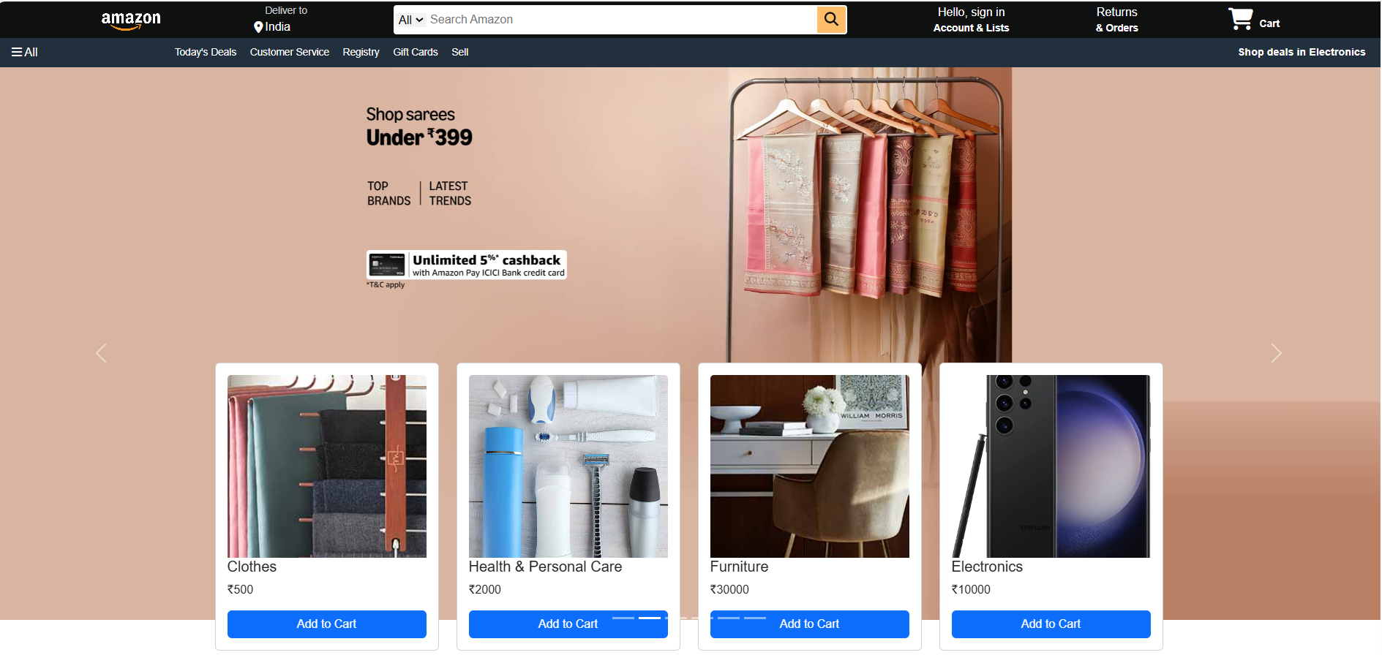

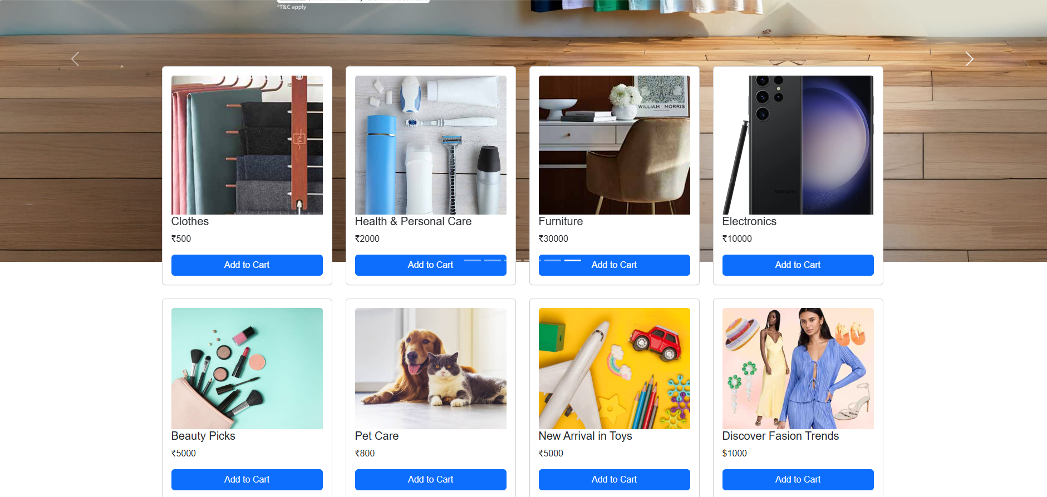

**FOOTER PAGE:**

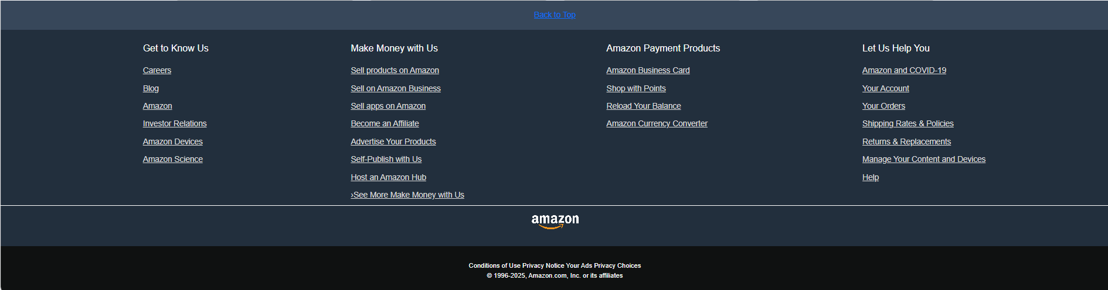

**MY CART PAGE:**

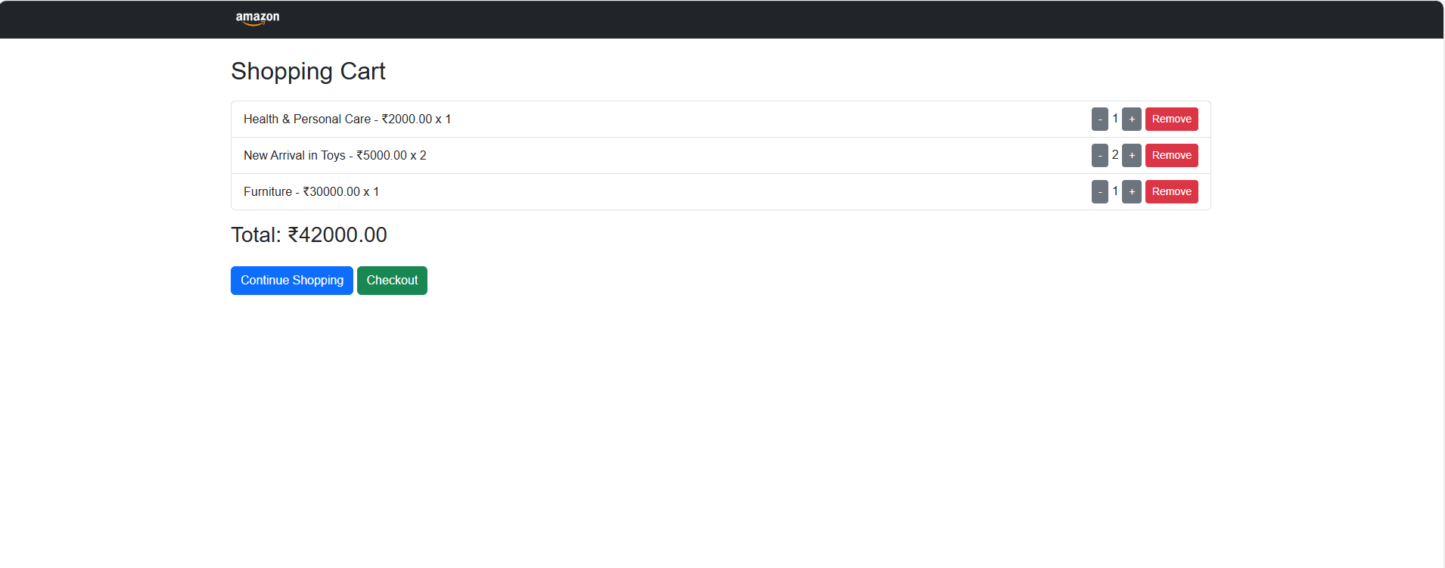

**PAYMENT PAGE:**

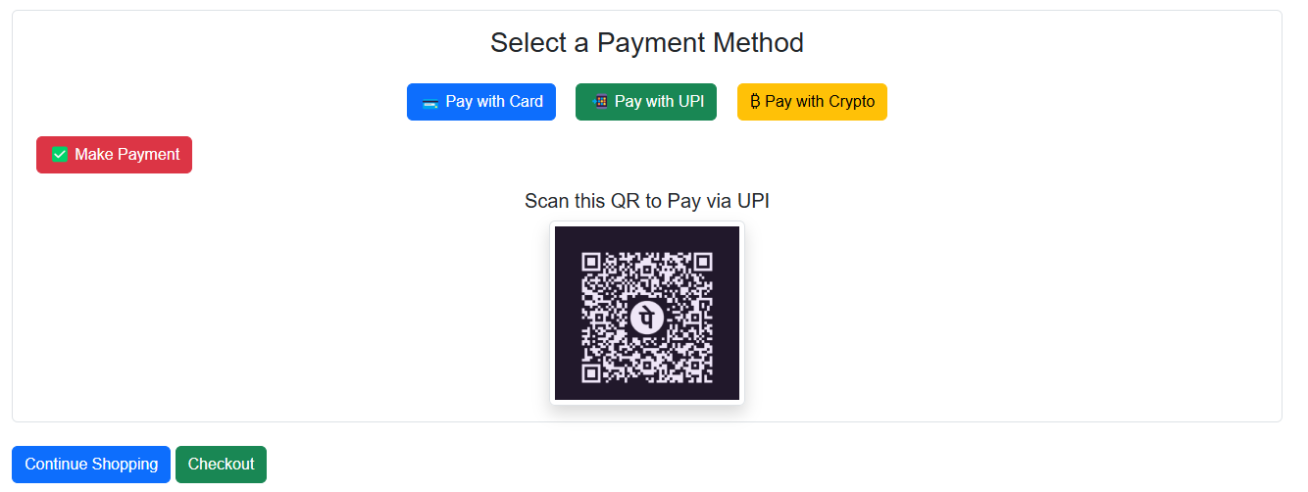

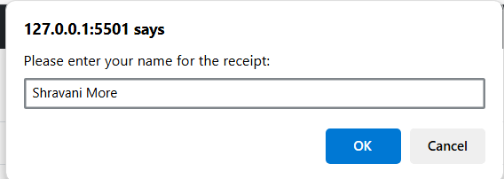

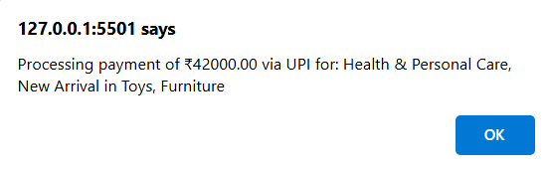

**PAYMENT RECEIPT PAGE:**

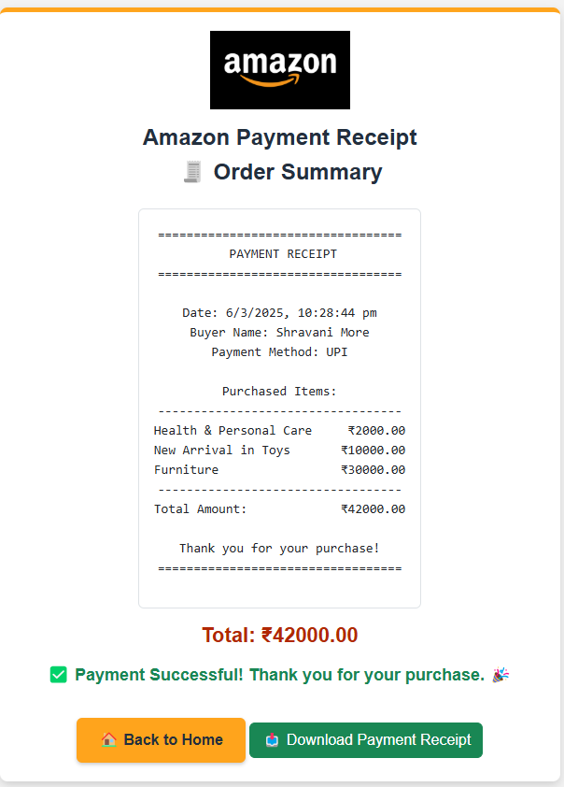

**Conclusion: -**

This project successfully delivers an Amazon-inspired e-commerce platform, ensuring a smooth and user-friendly shopping experience. It incorporates essential features such as secure authentication, seamless product browsing, an efficient checkout process, and invoice generation. With a well-structured and responsive design, the platform provides users with a reliable and convenient online shopping environment.

**Key Takeaways:**

✅ **User-Friendly Interface** – Intuitive navigation for easy product browsing.  
✅ **Product Management** – Organized product listings with categories and filters.  
✅ **Shopping Cart & Checkout** – Smooth cart operations and secure payment processing.  
✅ **Invoice Generation** – Automatically generates invoices for completed orders.  
✅ **Responsive Design** – Ensures compatibility across various devices.

This project lays a solid foundation for further enhancements, such as AI-powered recommendations and advanced analytics.